#### Project Design Phase-II

#### Technology Stack (Architecture & Stack)

|  |  |
| --- | --- |
| **Date** | **19 November 2022** |
| **Team ID** | **PNT2022TMID05601** |
| **Project Name** | **IOT Based Smart Crop Protection System for Agriculture** |
| **Maximum Marks** | **4 Marks** |

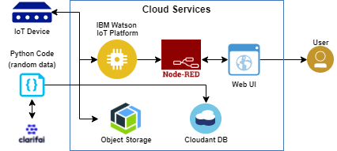

**Table-1 : Components & Technologies:**

|  |  |  |  |
| --- | --- | --- | --- |
| **S.No** | **Component** | **Description** | **Technology** |
|  | User Interface | How user interacts with application e.g.  Web UI, Mobile App, Chatbot etc. | HTML, CSS, JavaScript / Angular Js / React Js etc. |
|  | Application Logic-1 | Logic for a process in the application | Python |
|  | Application Logic-2 | Logic for a process in the application | IBM Watson/node red |
|  | Application Logic-3 | Logic for a process in the application | IBM Watson/node red |
|  | Database | Data Type, Configurations etc. | MySQL, NoSQL, etc. |
|  | Cloud Database | Database Service on Cloud | IBM Cloudant. |
|  | Temperature sensor | Monitor the temperature | TMP36 |
|  | Humidity sensor | Monitor the humidity | DHT11 |
|  | Soil moisture sensor | Measure the amount of water in the soil | Soil moisture sensor |
|  | Weather monitoring | Monitor the weather | Temperature sensor |

**Table-2: Application Characteristics:**

| **S.No** | **Characteristics** | **Description** | **Technology** |
| --- | --- | --- | --- |
|  | Open-Source Frameworks | Clarifai,Node- red | Software |
|  | Security Implementations | Sensitive and private data must be protected from their protection untill the decision-making and storage stages. | Encryption process |
|  | Scalable Architecture | Scalability is a major concern for IOT platform it has been shown that different architectural choices of IOT platform affect system capability and that automatic real time decision making is feasible in an environment composed of dozens of thousand. | Software |
|  | Availability | Automatic adjustment of farming equipment made possible by linking information like crops/weather and temperature,humidity etc. | Software |
|  | Performance | The ideas of implementing integrated sensors with sensing soil and environmental or ambient parameters in framing will be more efficient for overall monitoring . | Software |